Tamas Parasher

Add- 96, Brij Vihar, A.D.A Colony ,

G.T. Road, Aligarh (U.P)

Mobile No.- +91- 9992243348

E Mail: tamasparasher@gmail.com,

**Carrier Object:**

To work in the best environment to attain a responsibility. I want to become a part of your company and I can do take new responsibilities in my carrier and I would be ready for any difficult task in my carrier.

**Summary:**

**Profile :** Accountable for generating sales in old stock, strategic marketing, enhancing operational efficiency, maintaining client relations and managing a team.

* **Strategic Planning:** Assist in conducting market research, competitor intelligence and devising effective plan to increase market share of the product.
* **Sales Management:** Overseeing key functions involving sales strategies, new business development, maintaining dealer relations, enhancing service operational efficiencies.
* **Strategic Marketing:** Responsible for enhancing product visibility through effective product launches, innovative promotional programs and extensive policy programs.
* **Training:** Conducting major training programs for in-house staff dealers and technical orientation campaigns for customers.
* **Other Managerial functions:** Generating MIS reports and presenting to Senior management.

**Core Competencies:**

* Strategic Marketing & Sales
* Presentations & Proposals
* Direct Marketing Techniques
* Team Building & Leadership
* Business-to-Business (B2B) Territory Business Management

**Professional Experience:**

**ESCORTS LTD.**

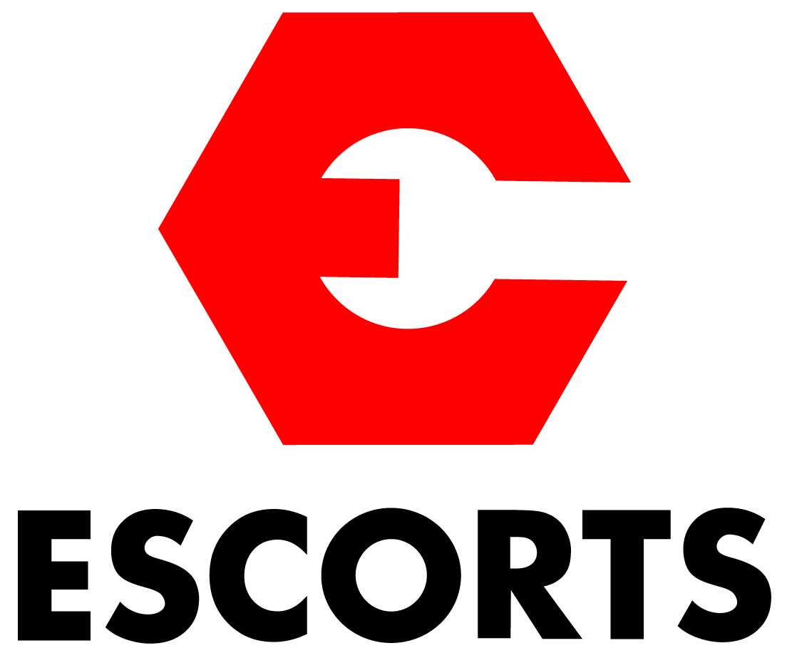

**Routine Sale & Marketing, in Powertrac Division (Sep 2020 to Present time) as a TBM.**

**(Asst. Manager –L02)**

**Profile:**

* I Handling new Opportunity in our organization as a **TBM Looking Dealer at Area in (Etah, Kashganj, Atrauli, Aligarh, Iglash, Khair)**
* Search New Dealer in Vacant Area.
* Implementation in Low Mkt. Industries Area.
* Appoint Sub Dealer and Sub branches in vacant Area.
* Increase Mkt. Share % and Number of Volume as per committed Senior and as per compare to Industries
* Conduct sales related meeting, Demo, Activity, with Customer in area
* Dealer DSE team Train new Product features and Sachems for growth in Business.

**Sale & Marketing, in Molanmol Business (May2017 to Sep2020) as a**



**(Asst. Manager –L02) (3 Year)**

**Profile:**

* Make a New Business Strategic for Molanmol Centre in Karnal Haryana. (2017)
* Conduct Business Planning for All Molanmol Centre Overall Process with Organize Management.

**Process of Molanmol Business-:**

1- How to Purchase Tractor for sale at Molanmol Centre.

2- Process of Tractor Deal with Customer.

3- Process of Retail Tractor.

4- Process of RTO, Finance work.

5- Payment Collection.

6- Payment Settlement through Company at time of Sourcing Tractors from Dealers, Customer, Broker.

* Make New Business Strategic Sales of New Tractor with Different Product Model as FT , PT & Steeltrac through Molanmol as Need of Customer.

**Achievements :**

Starting with 1 Molanmol Centre in (Karnal, Haryana)to end of the working in my job profile make new 7 Centre of different areas as (Faridabad, Rohtak, Agra, Vanaras, Kanpur, Barabanki, Alwar) complete Installation with Centre Team as all Business Parameters.

**Escorts Training Certificate- I have Participate with Escorts Tractor Training and received Certificate.**

**Professional Experience:**

**INTERNATIONAL TRACTORS LTD. (SONALIKA)**



**Territory Executive-Sale, Tractor Division (May 2012- Mar2017) ( 5 Year)**

**Profile:**

* Make a 1 new dealers and 4 Dealer Broker for Company Scrap Tractor of **Sonalika brand Tractors** of **International Tractors Ltd** . in Punjab and Haryana State which involves **LOI Process.**
* Independent handling of New Dealer for liquidate old tractor at locate my territory.
* Generating business from existing Broker, networking new Broker for business development. leading a team of dealers Sales executive‘s. for fast Liquidate Old Tractor.
* Appointment of Exchange Broker at dealerships for Liquidate Tractor Growth.
* Competitor Network Mapping and using same to analyses Exchange Mkt.
* Monitoring to the Dealer of Exchange Old Tractor Price Value.
* Responsible for all Market development activity like Broker Meet, Mechanic meet Customer Meet, loan mela, Bankers Meet, and also work on Old Tractor retail, advance, and deliver.
* Generating MIS reports and presenting it to senior Management.

**Achievements :**

* Appointed 1 New Tractor Dealers at Amritsar and also Give Dealer Party of area as Nawanshahar, Ludhiana, Khanna, Pathankot. (P.B) and Tawaru, (Sohna), Indri (Karnal) Haryana.
* Appointed 4Old Tractor Dealer in Patiala mkt. , Hoshiarpur, location in Punjab, and 2 Assndh Location in Haryana for **Sonalika Tractor.**
* Liquidate Old Tractor 500 Tractor As per my Resource. From the dealer point and company Scrap of R&D, Demo Tractor.

**Professional Experience**

**“ESCORT Tractor Dealership of Aligarh, Iglas, Khair as a Sales Trainee from 2009 to 2011. (2 Year)**

**Profile:**

* Maintain Relationship and achieve customer satisfaction
* Maintain the Reception counter any some time and Given the New Application Knowledge in New Tractor & Tractor Price, Finance System achieve by the Dealer to Customer.
* All these Activities Handling Like that Demo Stator, Road Show, Van Companying, Exchange Tractor Fair & Customer Meat, Mechanic Meat. Given by the Escort Tractor Company Plan at the Dealership.
* Work Maintain the Job card and manually work.
* Job card work on the computer online sends to company.
* Operating the company PMS Online Data Enter in New Customer Enquiry (Hot, Worm, and Cold) Collect by the Dealership Tractor Salesmen & Demo Plan.
* Operating the company EDMS Offline Data Entry & Made the Part Claim under Warranty Tractor at the Dealership.

**Achievements**:

**I have Received Best Trainee Certificate the Etrac PMS Executive Best Achievement Performance Grade By the Escorts Tractor Online Data Entry in Etrac.**

**Professional Experience**

**“Sundram Finance Group” of Chennai, Brach in Aligarh**.(U.P)



**Sales executive in Part time Six month 2008.**

**Profile:**

* Maintain Relationship and achieve customer satisfaction.
* Handling the hard & collection plan.
* Maintain Achieve all area of Aligarh city.
* Customer of L.I.C & Mutual Fund achievement.
* General Insurance of motor vehicle and finance.

**Computer Skills:**

Operating System: Window 98, XP

Microsoft Office: MS Office 2003 -7

**Technical Qualification:**

Three Year Diploma in Mechanical Egg. From Ghaziabad. (U.P) 2008.

**(BTE) Board of Technical Education.**

**Academic Qualification:**

* MBA from ISBM Chandigarh.2015
* B.Com from Agra University in 2008.
* Intermediate from U.P Board of Allahabad in 2005
* High School from U.P Board of Allahabad in 2003

**Strength:**

* Good Communication Skills.
* Ability to work under pressure.
* Perform well as a part of them.
* Ability to set along well with people.

**PERSONAL DETAILS:**

**Father’s Name :** Shri. Somveer Parasher

**Marital Status :** Unmarried

**Date of Birth :** 14th Jan. 1989

**Nationality :** Indian

**Declaration:**

**I hereby declare that all the information furnished above are complete and correct to of my knowledge & belief.**

**Date:**

**Place: Aligarh (U.P)**

**(Tamas Parasher)**